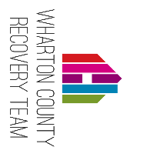

WHARTON COUNTY RECOVERY DOCUMENT REQUIREMENTS

Wharton County Recovery Team's mission is to assist in identifying disaster related recovery
needs and coordinate access to resources that will provide relief.

Office address: 307 West Milam Wharton, TX 77488 Office Number#: (979) 531-3170

☐Driver's License or Identification Card for all household members 18 or older.
☐Title or Deed to home damaged by disaster. Name on the title must match the applicant.
(Please inform case manager if otherwise for additional assistance)
☐FEMA documents (Award, Denial or Appeals letter) If flood insurance is mandatory please provide documents. Please contact FEMA at 800-621-3362 to request duplicate documents.
☐Insurance documents (Award, Denial or Appeal letters). If you don't have a copy, please contact your insurance company for a duplicate copy.
☐Proof of Earned Income (last three months)
☐Proof of Unearned income (Child Support, Disability, Social Security, VA Benefits, Retirement, Pension, Unemployment, Alimony)
☐2018 and/or 2019 Tax Returns. If you do not file income taxes, please provide a Verification of Non-filing letter. (Please contact IRS for duplicate documents at 800-908-9946)
☐Last three months of bank statements: _________________________________________.
☐Last month Utility Bills:________________________. 3 months Pre-disaster utilities.
☐Copy of receipts for verification of how recovery funds (FEMA, Insurance) were spent.
☐Pictures of damages (Interior and Exterior; date stamped), surveys and current permits issued for your property (if applicable).

Please contact the office once you have gathered all required documents to schedule an intake with a case manager.
**You may also email your documents to your case manager.
dcm1@whartoncountyrecoveryteam.org Jessica Williams
k.mathias@whartoncountyrecoveryteam.org Kim Mathias

Office hours: Tuesday, Wednesday & Thursday 8:30am to 4:30pm.
AUTHORIZATION TO RELEASE CONFIDENTIAL INFORMATION
I, the undersigned, authorize agency members of long term recovery task forces, committees, networks, the State of _ _Texas____, (FEMA) Federal Emergency Management Agency, and appropriate agencies of the State of ______Texas______ responsible for providing disaster assistance, to release information relating to my eligibility for monetary or other forms of assistance arising from the major disaster declared __DR4332 _ to those agencies that provide disaster-related or other assistance as is deemed necessary as the recovery process continues. This authorization permits the release of information that is deemed confidential under Federal and State Privacy Acts.

This authorization is given to obtain and/or provide assistance I need as a result of this federal disaster to insure that benefits are not duplicated and that all benefits available to me are accessed. It includes the sharing of information about my application for services or assistance from any participating agency.

This authorization includes only information necessary to allow the appropriate agency or organization to determine if I am eligible for assistance or referral from that agency or organization. This information is not to be used for any other purpose.

I also understand and acknowledge that signing this does not guarantee that I will get assistance from voluntary agencies and/or appropriate federal and state agencies. However, without my permission my information cannot be shared with other agencies or organizations for consideration. I understand I will still receive all FEMA assistance for which I am eligible.

This authorization is submitted pursuant to 28 U.S.C. § 1746 under penalty of perjury.

I understand the three exceptions to the confidentiality agreement
- If I give permission to share information
- If there is a disclosure of abuse of a child, elder, or disabled person
- If I threaten to harm myself or someone else

OPTIONAL- I choose to exclude the following agencies from access to this information:
__________________________________________________________________________

I understand that it is my choice to sign this release.

____________________________________________________________________________
Name (Printed) Date

____________________________________________________________________________
Signature Date

Pre-Disaster Address:_____________________________________________________________

Current Address:_________________________________________________________________

Phone/Message#:______________________ FEMA Registration#:_______________________

Application for Recovery Services

Primary Applicant_____________________________________________________________________
Pre-Disaster Address_____________________________________________________________
Current Address_________________________________________________________________
Phone: (H)__________________(W)_________________Is it OK to call you at work? (Y)__(N)__
Email address:________________________________________________________________________

Co-Applicant (if applicable)______________________________________________________________
Pre-Disaster Address_____________________________________________________________
Current Address_________________________________________________________________
Phone: (H)__________________(W)_________________Is it OK to call you at work? (Y)__(N)__
Email address: ________________________________________________________________________

Household Composition- List all current household members. (Please attach a separate sheet of paper for additional household members.)
 | Household Member | Relationship | DOB | Gender | Ethnicity
1. |  | HOH
2.
3.
4.
5.
*Proof of relationship to head of household will be required
Pre-Disaster Residence Information:
Where you the owner of the home damaged by disaster on 8/25/2017? ______________________________
Do you currently own the home damaged by disaster on 8/25/2017? _________________________________
Do you currently live in the home? _____________________________________________________________
Was the damaged home your primary address on 8/25/2017?_______________________________________

Damaged Property Information:
Is the damaged property in a floodway or floodplain? _________________________________________
Is the property tax current on damaged property? __________________________________________
Is there a lien on the damaged property? ___________________________________________________
Are you in the process of foreclosure? _____________________________________________________
Are there other heirships to the damaged property? __________________________________________
Was this property: Inherited? _______ Gifted? ______ Purchased with a mortgage? ______
Purchased with cash? ______
At the time of disaster, on 8/25/17, was there homeowner’s insurance on the damaged property? __________
At the time of disaster, on 8/25/17, was there flood insurance on the damaged property? _________________

Gross Household Income:
Head of Household (monthly) $________________
Source(s) _________________
Co Applicant (monthly) $ ______________________
Source(s) _________________
Other Income (monthly) $______________________
Source(s) _________________
Monthly Living Expenses:
Mortgage _____________ Rent_______________
Car Payments__________ Food_____________
Medication________ Alimony______________
Child Support ________ Personal Loans __________
Resources:
Cash on hand in bank: $_________________ Insurance $__________________________
FEMA Assistance: $ ____________________ American Red Cross $ _________________
SBA Loan Amount: $ ____________________ Other Need Assistance $________________
Temporary Housing $ ___________________ Home Repair/Replacement $ ____________
Financial Assistance $___________________ Other Gov’t Programs __________________
Family or Friends Assistance $ ____________

I have applied for, and was denied assistance by General Land Office? ___________________________
I have applied for, and was denied assistance by Samaritans Purse? _____________________________

Do you own other property, in your name or heirship, other than the damaged property named above? __________________________________________________________________________________________
If yes, please include address(es): __________________________________________________________________________________________

Disaster-Related expenditures (out of pocket expenses):
Crisis Needs ____________________
Clothing ____________________
Furniture and household items ____________________
Emergency repairs to structure ____________________
Other (explain) ____________________

What resources/assistance would you like for Wharton County Recovery Team to assist you with?
__________________________________________________________________________________________________________________________________________________________________________________________________________________________________________________________________________________________________________________________________________________________________________________________________________________________________________________________________

Additional Comments:________________________________________________________________________
______________________________________________________________________________________________________________________________________________________________________________________________________________________________________________________________________________

UNMET NEEDS (Sharing information)

APPLICANT STATEMENT: I agree and affirm that I am making voluntary application for assistance for disaster relief from Special Unmet Needs Committee. I understand that the information contained in this application and the accompanying Individual/Family Plan for Recovery and the Release of Confidential Information form will be utilized by Special Unmet Needs Committee to assist me with my disaster-related needs. I understand that assistance is not guaranteed and that the case manager does not make the final determination of the availability of funds or other kinds of help. My signature below signifies that I have read and /or understand this document and the service being provided me.

Signature of Applicant ____________________________________________Date_____________

Signature of Co Applicant ________________________________________Date_____________

CLIENT RESPONSIBILITY FORM

I realize it is important that I contribute all that I can to my own recovery from Hurricane Harvey.

I agree to report and contribute any financial assistance that I have received from
- FEMA
- Faith based organizations or churches
- The Salvation Army
- V.O.A.D. member agencies
- Non-governmental assistance
- State or local Recovery Task Forces/Committees
- State and/or local government
- Community Education
- Community Services Board
- Department of Social Services
- Private funds
- Insurance
- Any other resources not listed

I also agree to use any resources I have, including financial and human to assist in my own recovery. I understand that I am responsible for my own recovery.

If at any time in the past I have received benefits I will use my resources first to assist in my recovery. In the future if I receive proceeds from a source for an item of personal property or repairs to my home, I will return additional money to the appropriate agency to avoid duplication of benefits. I understand all income and/or benefit sources are subject to verification by casework representative of the Unmet Needs Committee and that I may be denied assistance for giving false information.

Applicant Signature_______________________________________ DATE_________________

Co Applicant Signature_____________________________________ DATE_________________

Applicants Certification

Please Initial.
______ I have answered all the question on my application truthfully and to the best of my own knowledge. I understand that any information that is not truthful can disqualify me and my household from previous and future approval of services.

______ I understand this application is not a guarantee of service(s). All information provided to Wharton County Recovery Team with be evaluated and a determination will be made if applicant is eligible.

________ I agree that myself or someone in the household meet one or more of the following criteria:
- Racial and ethnic minorities living in poverty
- Limited English proficiency (identified as primarily Spanish speakers)
- Persons with special access and functional needs, including hearing, vision, cognitive, ambulatory, self-care and/or independent living difficulties
- Elderly persons (over 65)
- Households with children under 18
- Female heads of household
- Veterans – (DD-214)
- Displaced homeowners
- Homeowners within a FEMA-designated flood hazard zone

Signature of Applicant ____________________________________________Date_____________

Signature of Co Applicant ________________________________________Date_____________

Client Authorization
I authorize the entity to which I am applying for assistance to obtain information about me and my household that is pertinent to determining my eligibility for participation.
I acknowledge that:
• A photocopy of this form is as valid as the original; AND
• I have the right to review information received using this form; AND
• I have the right to a copy of information provided
• All adult household members (18 and over) will sign this form and cooperate with the eligibility verification process.
• My documents may become electronically permanent.

Please note: By signing this application, the applicant(s) authorizes the Wharton County Recovery Team or any of its duly authorized representatives to verify information provided is correct.
Signature of Applicant: ____________________________________________________ Date: _____________
Signature of Co-applicant: __________________________________________________ Date:_____________
Signature of adult household member: ________________________________________Date: _____________
Signature of adult household member: ________________________________________Date: _____________

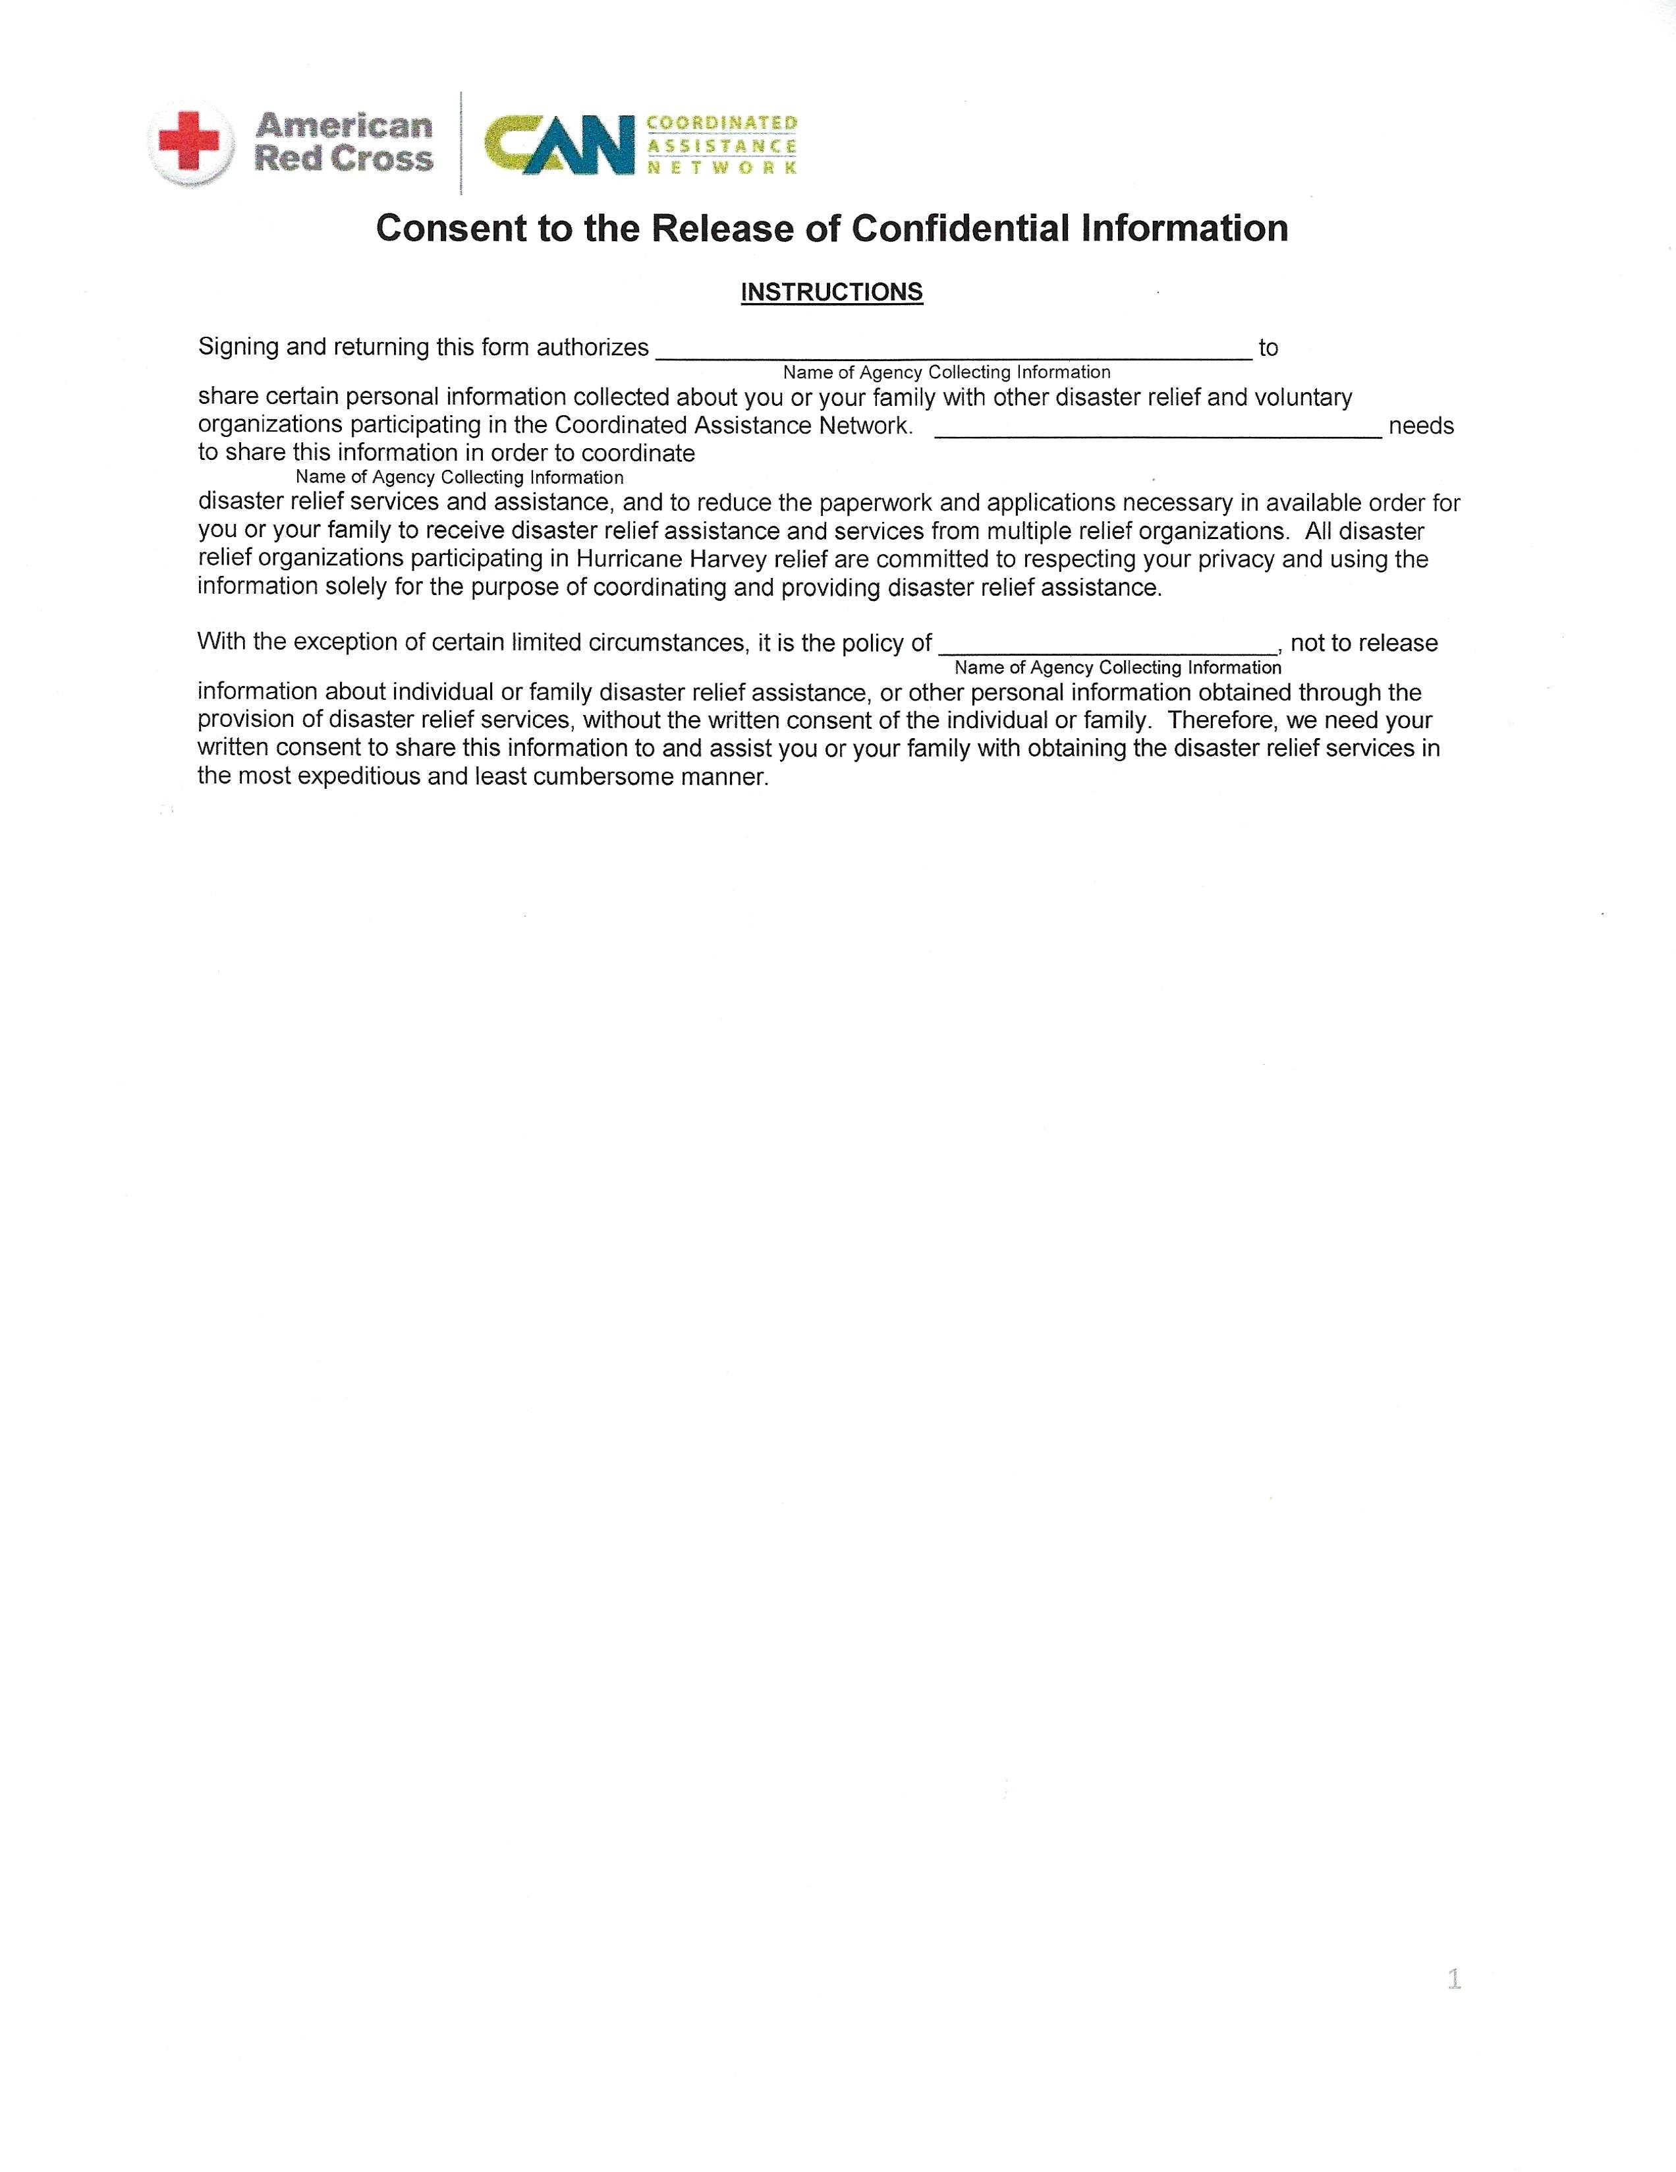
Wharton County Recovery Team

Wharton County Recovery Team

Wharton County Recovery Team

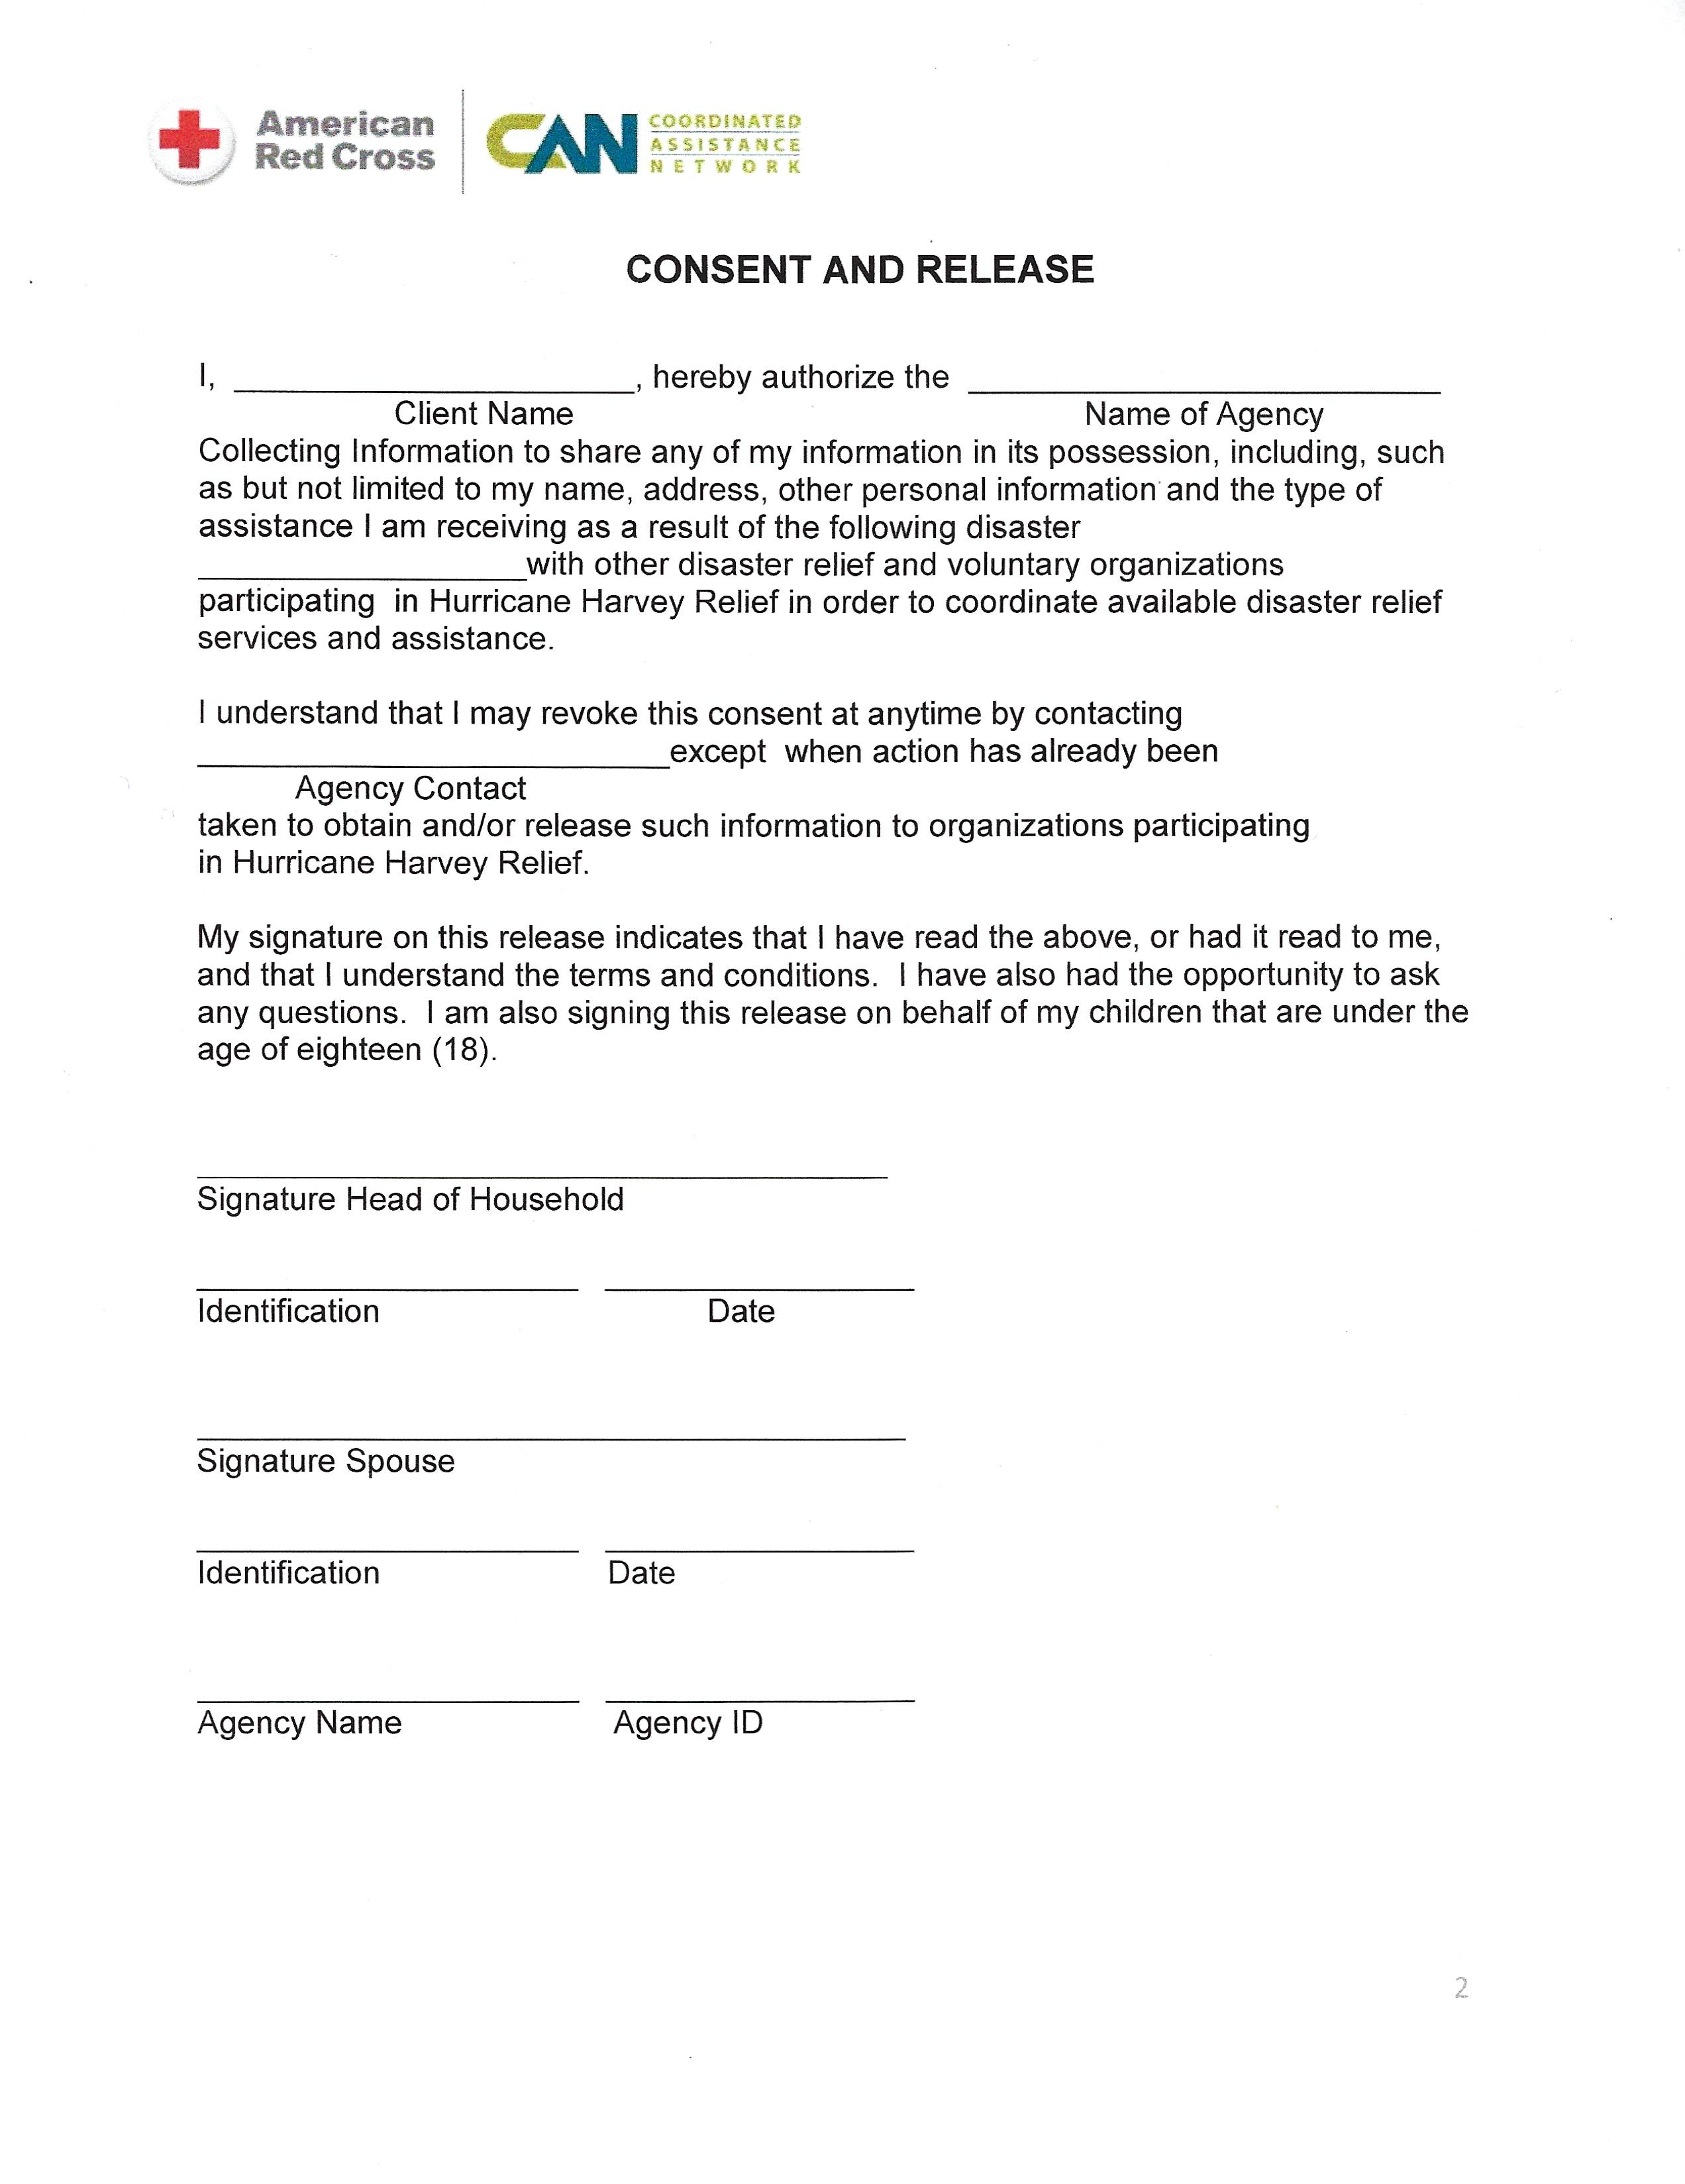
162

Wharton County Recovery Team

Wharton County Recovery Team

DR4332

Wharton County Recovery Team

