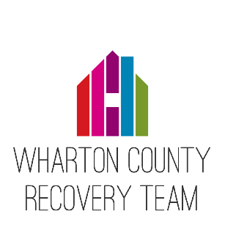

P R E S S R E L E A SE
For Immediate Release
December 10, 2018

The Wharton County Recovery Team recently received a $1,467,875 grant from the Rebuild Texas Fund on behalf of the Wharton West End Initiative. The Rebuild Texas Fund is a collaborative project of the Michael & Susan Dell Foundation and the OneStar Foundation. The Rebuild Texas Fund supports organizations making an impact to rebuild the communities in Texas affected by Hurricane Harvey in the following in the following six focus areas: community and economic development; health; housing; education and childcare; transportation and workforce; and capital for rebuilding small businesses. The Wharton County Recovery Team and the Rebuild Texas Fund, are committed to rebuilding our community through this grant alongside all of you.
Specifically this grant will go towards the Wharton West End Project whose goal is to rebuild 40 homes on the West End of Wharton, a neighborhood where flooding due to Harvey was particularly devasting. The Wharton West End Initiative has been working since hurricane Harvey to develop recovery solutions and resilience in the community. The West End Initiative and The Wharton County Recovery Team are collaborating on the West End Project.
“We applied for a grant through the Rebuild Texas Fund because we are committed to our community and seeing this area rebuild after Hurricane Harvey,” says Melissa Burnham of the West End Initiative. “We know that rebuilding after this storm will take many of us working together to solve big challenges and are excited to see change and improvements due to this grant and collaborative effort,” adds Carol Wootton of the Wharton County Recovery Team.

