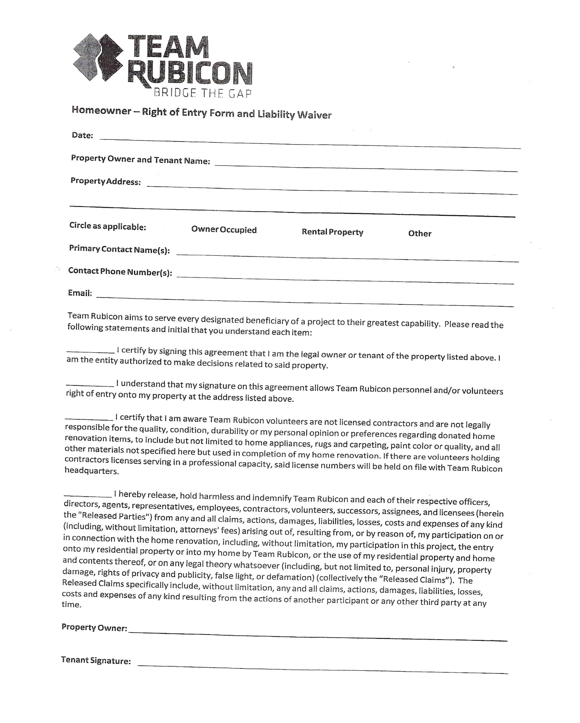

This is a check list for each household to see what stage of recovery the survivor is at with their home. After residents answer this questionnaire they will need to sign a liability waiver.
- What type of structure is your home built on?
- Concrete slab
- Peer and beam
- Mobile home
- Have you mucked out your home? Explain what this means.
- Yes
- No
- Have you done mold remediation on your home? Air testing ect.?
- Yes
- No
- What type of damage do you have on your home?
- Roof damage
- Plumbing issues
- Electrical damage
- Water well damage
- Sewage drainage issues
- Floors/sub flooring
- House exterior
- House interior
- Mold

- Do you have current permits for construction on your home? Could you obtain permits for your home?
- Yes
- No
- Do you rent or own your home?
- Rent
- Own
- Do you have the deed to your home?
- Yes
- No
- Do you know what materials you would need to finish your home?
- Yes
- No

- Would you be able to wait for a start date of July 14th to get help on your home?
- Yes
- No

