AUTHORIZATION TO RELEASE CONFIDENTIAL INFORMATION

I, the undersigned, authorize agency members of long term recovery task forces, committees, networks, the State of _ _Texas____, (FEMA) Federal Emergency Management Agency, and appropriate agencies of the State of ______Texas______ responsible for providing disaster assistance, to release information relating to my eligibility for monetary or other forms of assistance arising from the major disaster declared __Hurricane Harvey _ to those agencies that provide disaster-related or other assistance as is deemed necessary as the recovery process continues. This authorization permits the release of information that is deemed confidential under Federal and State Privacy Acts.

This authorization is given to obtain and/or provide assistance I need as a result of this federal disaster to insure that benefits are not duplicated and that all benefits available to me are accessed. It includes the sharing of information about my application for services or assistance from any participating agency.

This authorization includes only information necessary to allow the appropriate agency or organization to determine if I am eligible for assistance or referral from that agency or organization. This information is not to be used for any other purpose.

I also understand and acknowledge that signing this does not guarantee that I will get assistance from voluntary agencies and/or appropriate federal and state agencies. However, without my permission my information cannot be shared with other agencies or organizations for consideration. I understand I will still receive all FEMA assistance for which I am eligible.

This authorization is submitted pursuant to 28 U.S.C. § 1746 under penalty of perjury.

I understand the three exceptions to the confidentiality agreement
- If I give permission to share information
- If there is a disclosure of abuse of a child, elder, or disabled person
- If I threaten to harm myself or someone else

OPTIONAL- I choose to exclude the following agencies from access to this information:
__________________________________________________________________________

I understand that it is my choice to sign this release.

__________________________________ ______________________________
Name (Printed) Date

__________________________________ ______________________________
Signature Date

Pre-Disaster Address:_____________________________________________________________

Current Address:_________________________________________________________________

Phone or Message#:______________________ FEMA Registration#:_____________________

Case File Number: _________________Date Opened: _____________Date Closed: _________

Application for Recovery Services

WARNING: The information contained in this application is protected by federal Privacy Act laws and must be kept completely confidential. Upon Completion, the client is entitled to review its contents, comment upon it, and sign it.

Name_________________________________________________________________________
Pre-Disaster Address_____________________________________________________________
Current Address_________________________________________________________________
Phone: (H)__________________(W)_________________Is it OK to call you at work? (Y)__(N)__
Alternate phone___________________ When is the best time to call?___________
Total number living in the home__________
Number of Adults_____ Number of Children_____
Pre-Disaster Residence Information:
_____Own ____Rent
_____Single-family dwelling _____Multiple Housing _____Duplex _____Other(explain)
_____Destroyed _____Major Damage _____Minor Damage
_____Insurance Coverage: ( ) Structure ( ) Contents ( ) Flood
Gross Income:
Current for head-of –household________________
Source(s)_________________
Current for Spouse__________________________
Source(s)_________________
Current for others in household________________
Source(s)_________________
Monthly Living Expenses:
Rent_____________ Utilities_______________
Mortgage_________ Car Expenses__________
Food_____________ Other Expenses_________
Medication________ ______________________
Home owner? _____Yes _____No

Resources:
Cash on hand in bank:_________________ Insurance___________
FEMA Assistance:__________________ Red Cross___________
SBA Loan Amount:____________________ ONA________________
Other___________________________________________________________
Disaster-Related expenditures already made or to be made:
Crisis Needs ____________________
Clothing ____________________
Furniture and household items ____________________
Emergency repairs to structure ____________________
Other (explain) ____________________

Assistance Received (include amount and type):
Federal assistance received: FEMA #_________________________
_____Temporary housing/Direct Housing
_____Home Repair/Replacement
_____Financial Assistance
_____ONA
_____SBA loan
_____Other Gov’t Programs
Other Assistance Received:
Assistance received from any agency sources, such as American Red Cross, voluntary/faith-based organizations. Include State agency/departments, etc.
List dollar amounts and assistance received, e.g., clothing, food, medical, etc. ______________________________________________________________________________
____________________________________________________________________________________________________________________________________________________________
Assistance received from family or friends. List dollar amounts and types.
______________________________________________________________________________
____________________________________________________________________________________________________________________________________________________________
______________________________________________________________________________

Are insurance, federal, state, and /or family resources sufficient to meet disaster-caused needs?
_____Yes _____No If no, please explain:________________________________________
__________________________________________________________________________________________________________________________________________________________________________________________________________________________________________
______________________________________________________________________________
Recovery Plan
Has family established a plan for recovery? _____Yes _____No
If yes, describe: __(see attached recovery plan)____________________________________
____________________________________________________________________________________________________________________________________________________________
What remains to be done? Describe the individual’s/family’s stated unmet need(s). Be specific.
______________________________________________________________________________________________________________________________________________________________________________________________________________________________________________________________________________________________________________________________________________________________________________________________________
Has the family obtained estimates for repairs or replacement of residence? _____Yes _____No
________________________________Estimate by:
________________________________Estimate by:

Obtained permits/inspections? _____Yes _____No
Checked elevation requirements? _____Yes _____No

Case Manager’s Assessment
Is further agency involvement needed? _____Yes _____No
Explain:________________________________________________________________________
__________________________________________________________________________________________________________________________________________________________________________________________________________________________________________
__________________________________________________________________________________________________________________________________________________________________________________________________________________________________________

Are there other needs identified in the family that need referral to another agency?
Yes _____No_____
If yes explain:___________________________________________________________________
____________________________________________________________________________________________________________________________________________________________
____________________________________________________________________________________________________________________________________________________________
Additional Comments:_____________________________________________________________
________________________________________________________________________________________________________________________________________________________________________________________________________________________________________________________________________________________________________________________

APPLICANT STATEMENT: I agree and affirm that I am making voluntary application for assistance for disaster relief from Special Unmet Needs Committee. I understand that the information contained in this application and the accompanying Individual/Family Plan for Recovery and the Release of Confidential Information form will be utilized by Special Unmet Needs Committee to assist me with my disaster-related needs. I understand that assistance is not guaranteed and that the case manager does not make the final determination of the availability of funds or other kinds of help. My signature below signifies that I have read and /or understand this document and the service being provided me.

Signature of applicant____________________________________________Date_____________

Witness (case worker’s signature)__________________________________Date_____________

CLIENT RESPONSIBILITY FORM

I realize it is important that I contribute all that I can to my own recovery from _Hurricane Harvey_.

I agree to report and contribute any financial assistance that I have received from
- FEMA
- Faith based organizations or churches
- The Salvation Army
- V.O.A.D. member agencies
- Non-governmental assistance
- State or local Recovery Task Forces/Committees
- State and/or local government
- Community Education
- Community Services Board
- Department of Social Services
- Private funds
- Insurance
- Any other resources not listed

I also agree to use any resources I have, including financial and human to assist in my own recovery. I understand that I am responsible for my own recovery.

If at any time in the past I have received benefits I will use my resources first to assist in my recovery. In the future if I receive proceeds from a source for an item of personal property or repairs to my home I will return additional money to the appropriate agency to avoid duplication of benefits. I understand all income and/or benefit sources are subject to verification by casework representative of the Unmet Needs Committee and that I may be denied assistance for giving false information.

CLIENT SIGNATURE_______________________________________DATE_________________

WITNESS SIGNATURE_____________________________________DATE_________________

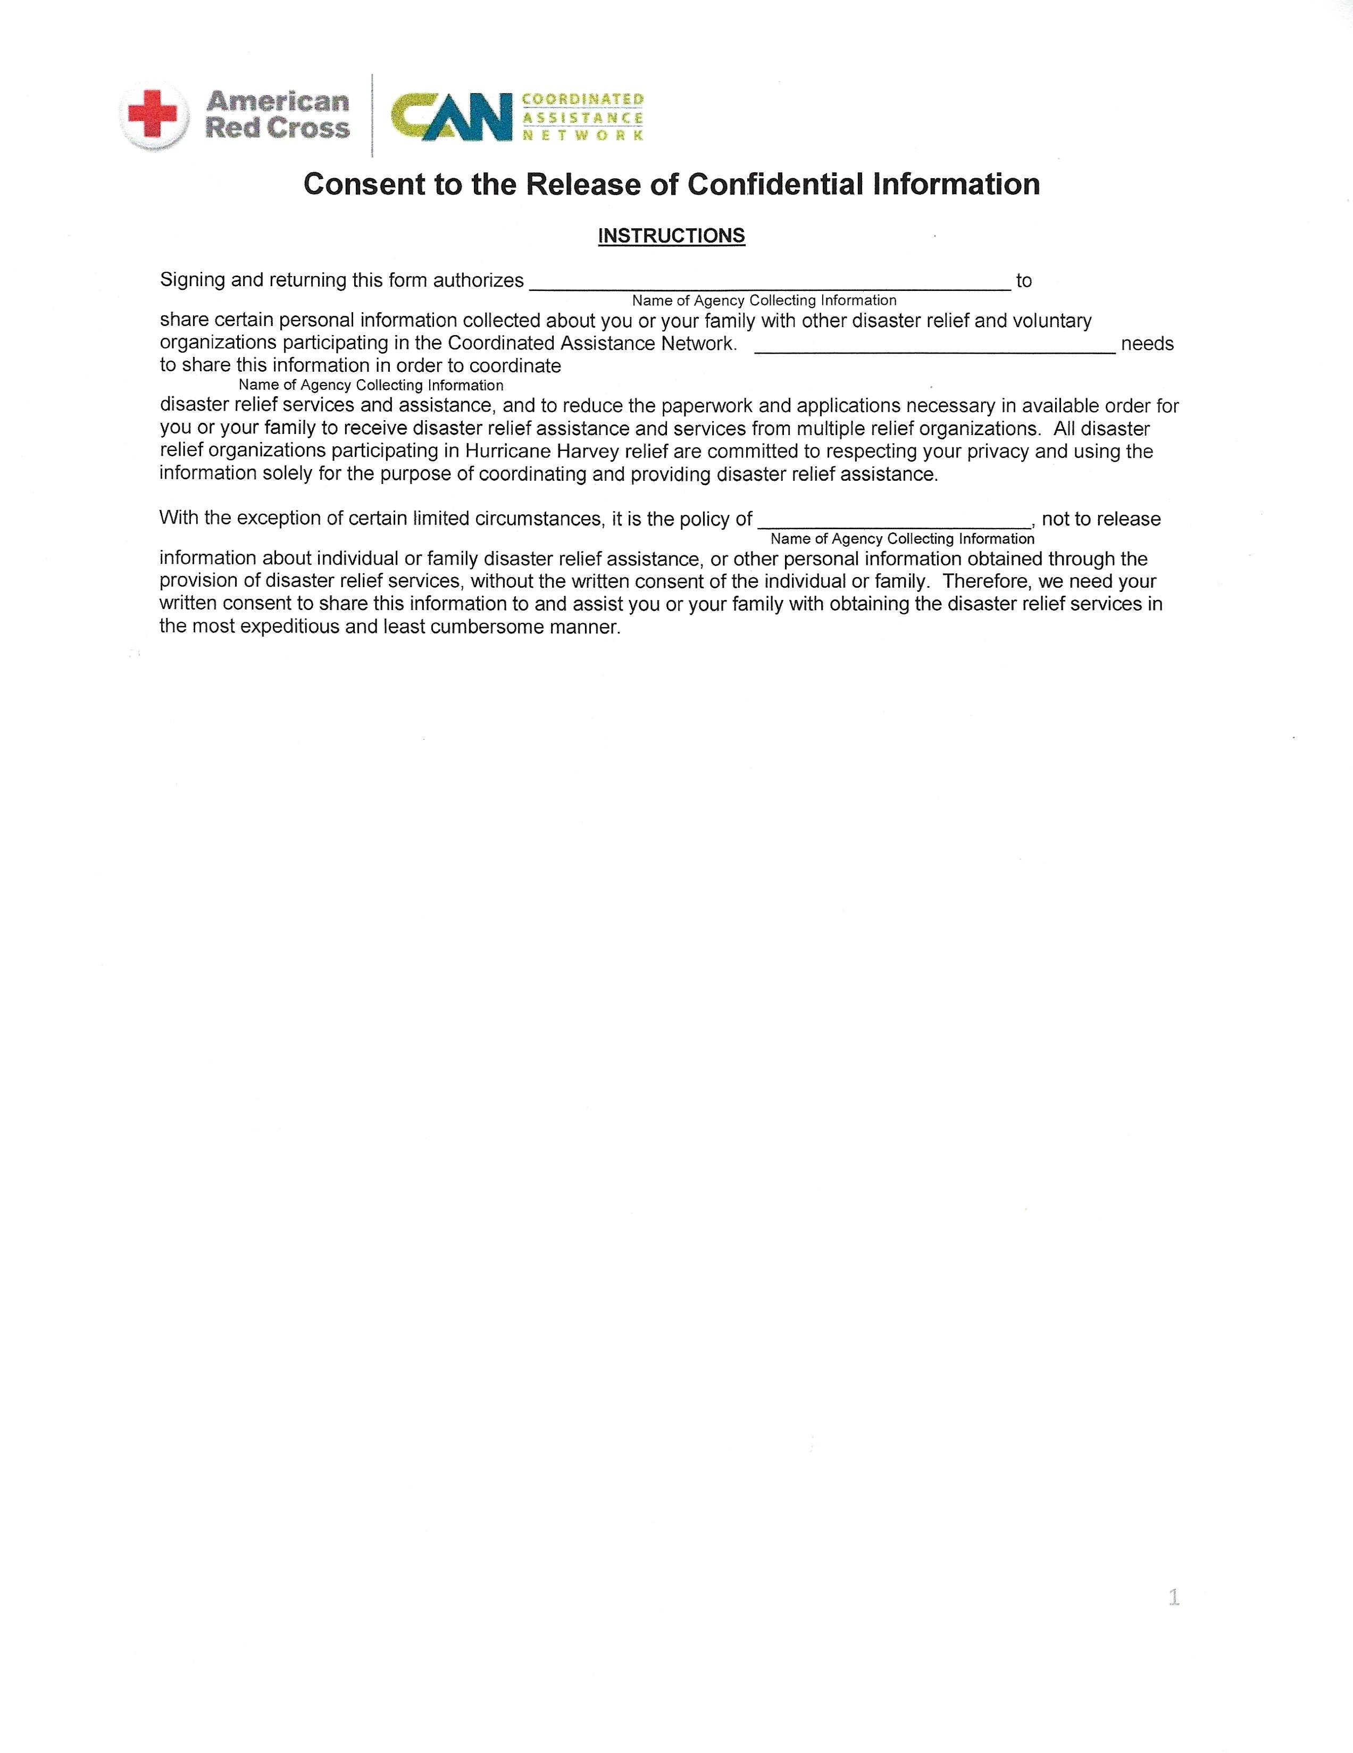
Wharton County Recovery Team

Wharton County Recovery Team

Wharton County Recovery Team

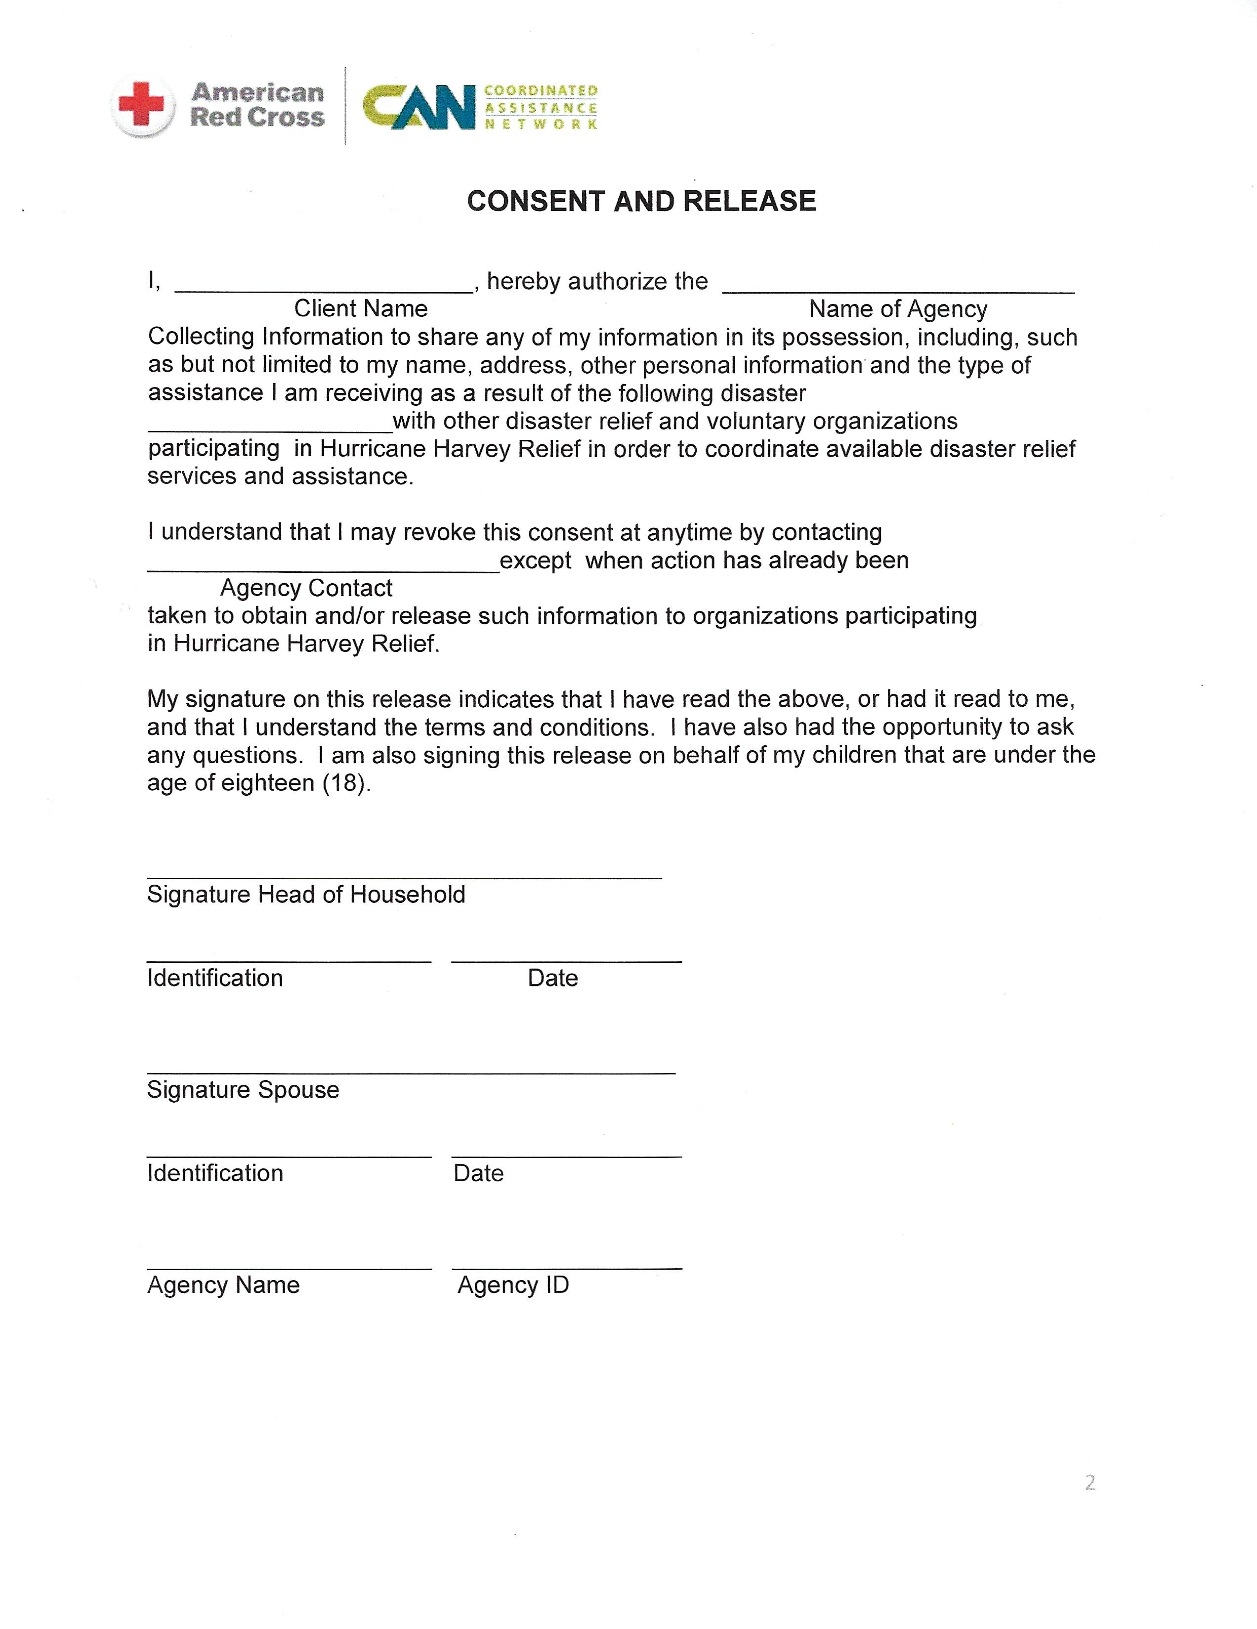
162

Wharton County Recovery Team

Wharton County Recovery Team

Hurricane Harvey

Wharton County Recovery Team

